CYB102 Milestone 2 (🔗 Instructions Page)

Team Members (Required) - Group 49
Reminder: Make sure to provide edit access for this Milestone document to everyone on your team!
👤 Student Name:  💬 Student Pronouns:  ✉️ Student Email:  🐹Favorite Animal: | Elhassan Elboraey  he/him  alhassan@uni.minerva.edu  Dolphins | 👤 Student Name:  💬 Student Pronouns:  ✉️ Student Email:  🍦Favorite Flavor: | Maria Hossain  She/Her  Mariakomol18@gmail.com  Chocolate
👤 Student Name:  💬 Student Pronouns:  ✉️ Student Email:  🎡Favorite Park: | Viridiana Ramos Ayala  She/Her  vramosayala@csumb.edu  Santa Cruz Boardwalk | 👤 Student Name:  💬 Student Pronouns:  ✉️ Student Email:  🎮Favorite Game: | Stephanie Zhai  She/Her  stephaniezhai537@gmail.com  Zip (LinkedIn games)
👤 Student Name:  💬 Student Pronouns:  ✉️ Student Email:  ☕Favorite Drink: | Shireen M  She/her  Sxxxxxxx@gmail.com  Natural Electrolyte Beverages | 👤 Student Name:  💬 Student Pronouns:  ✉️ Student Email:  🎨Favorite Color: | Weiting Gao  He/his  chrislife@secoryx.com  Green
What are pronouns /
Why are they included here?

Answer each of the key aspect questions (Required)

Instructions: For each of the key aspects below, include a few sentences explaining how your project is demonstrating that aspect. Please include at least one specific example.

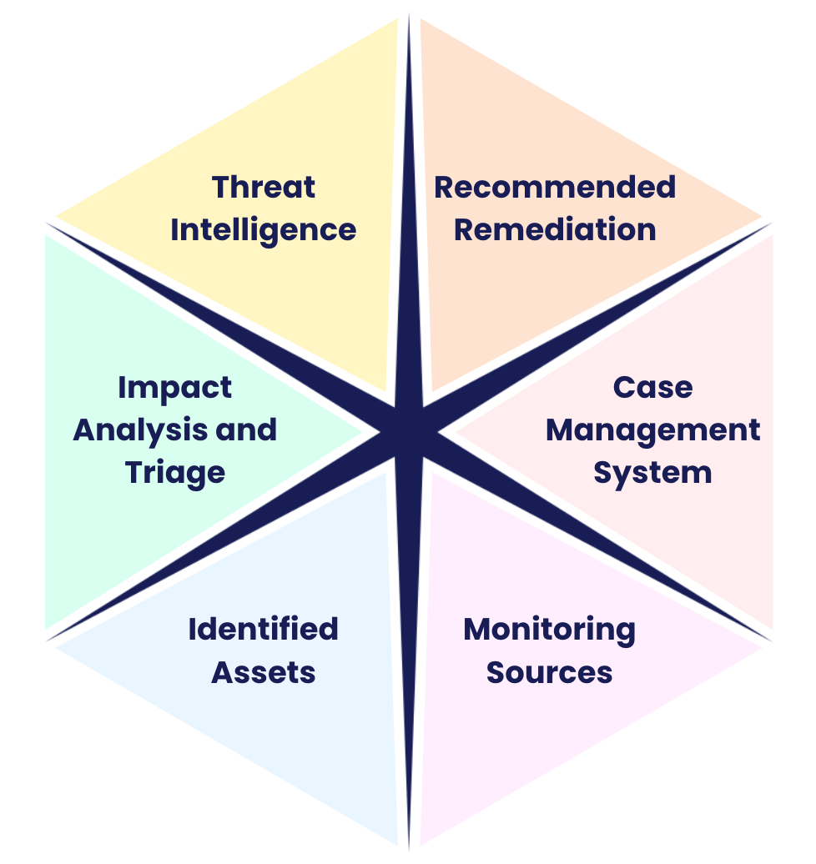
For a full definition of each of the key aspects, please
view the Data Dig Project page on the Course Portal.

Monitoring Sources
How it relates to our project: | We need to analyze who is attempting to access file resources for those who were not authorized prior. We utilized Splunk because it does a good job organizing and filtering the dataset making finding information much easier and faster. We were able to view the users, the software they used, and what bucket they were trying to access.
Example(s): | Used Splunk. Have information of their IP addresses and what source they tried to access

Identified Assets
How it relates to our project: | The asset we focused on was the microsoft-devtest S3 bucket itself. It’s a honeybucket, so it doesn’t hold real data but it’s built to look like a normal dev/test storage location to anyone scanning for exposed buckets. Treating it as our protected asset gave us a baseline for what “normal” access should look like so anything outside that stood out.
Example(s): | Every interaction with the bucket (like LIST, GET and PUT) was logged and pulled into splunk. Since the bucket holds no sensitive data, our concern wasn’t data exposure but rather understanding attacker behaviour such as who found it, how they found it and what they tried to do once they got access.

Impact Analysis and Triage
How it relates to our project: | Since our dataset is a simulated honeybucket, it contains no real company data, so the actual business or data-loss impact is zero. Because of that our triage focused less on "what was lost" and more on measuring the exposure window and how far each unauthorized actor progressed through the attack chain. By analyzing the chronological sequence of events in Splunk, we could determine whether an actor stopped at simple reconnaissance or escalated toward an actual write attempt.
Example(s): | Most source IPs stopped after a single HeadBucket or ListObjects call, indicating passive discovery only. However, a small number of IPs escalated further four separate PutObject attempts were identified in our dataset, showing that certain actors moved beyond scanning and attempted to write data into the bucket, which we treated as a higher-priority triage tier than simple reconnaissance traffic.

Threat Intelligence
How it relates to our project: | This relates to our project by helping us figure out who's accessing the bucket and what they're actually trying to get to. If one specific request keeps showing up way more than others that tells us there's likely something specific the attacker is interested in, not just random poking around. When we noticed patterns like this, we'd log it as a ticket in Catalyst so the rest of the team was aware and could follow up if needed.
Example(s): | We noticed one IP, 3.94.59.56, had 62 repeated attempts trying to access the bucket way more than anything else we saw, which made it stand out immediately.  Another IP, 54.175.203.19, wasn't far behind with 58 attempts of its own. When we looked these up, a few of the IPs in our list like 64.15.129.102 and 93.100.136.232 actually came back flagged as malicious on VirusTotal, which confirmed these weren't just harmless one-off scans.  We also noticed that a lot of the activity was IPs just checking if the bucket existed or trying to list what was inside it, rather than actually pulling specific files, which told us most of what we were seeing was still in the "scoping it out" stage rather than a full-blown attack.

Recommended Remediation
How it relates to our project: | What we learned from watching the honeybucket gave us a pretty clear picture of what to actually recommend if this were a real production bucket. Since we got to see exactly how attackers behave, what they check first, how often they retry, what tips them into escalating we could turn that into concrete steps instead of just generic security advice.
Example(s): | Set Up Smarter Alerts: Since we saw that repeated HeadBucket and ListObjects calls from the same IP were a strong sign of scanning, we'd recommend building alerts around that exact pattern for real buckets, so a security team gets flagged the moment something starts poking around instead of finding out after the fact.  Lock Down Access by Default: A lot of what we saw only happened because the bucket was reachable in the first place. For real assets, we'd recommend making sure S3 buckets stay private by default and are only opened up when there's a clear business reason to do so.  Use This Data for Red Team Practice: Since we now have real examples of attacker behavior the escalation from scanning to actual PutObject attempts, the repeat offenders, the automated-looking traffic that data could be reused to simulate similar attacks against our own systems and see how well our team actually catches and responds to it.

Case Management System (and screenshots)
How it relates to our project: | Catalyst gave us a central place to actually document what we found in Splunk as a formal case, rather than just leaving it as search results sitting in a query window. Logging everything through Catalyst meant our team could all see the same evidence, add notes as we went, and keep a clear record of what happened and when which matters if this ever needed to be reviewed or handed off to someone else.
Example(s): | Incident Details:  - Incident ID: #16904 - Unauthorized Discovery Activity Against microsoft-devtest S3 Bucket  - Status: Open  - Opened: 2026-07-31, 06:11 AM  - Severity: Medium  - TLP: Amber  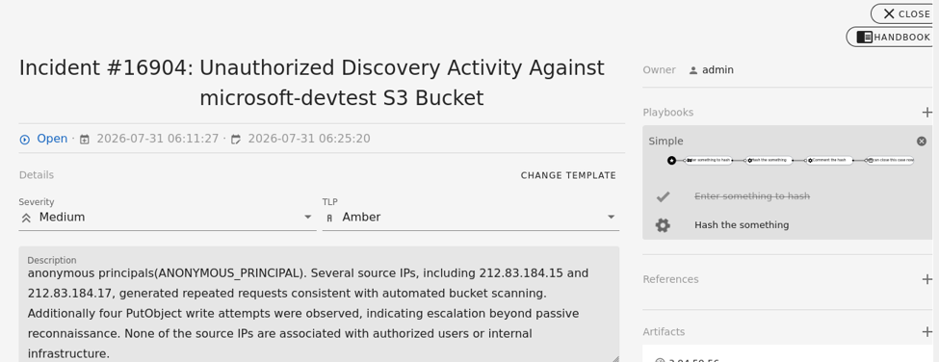  Description:  Our Splunk analysis flagged repeated HeadBucket and ListObjects calls hitting the microsoft-devtest bucket all coming from anonymous principals rather than any authenticated or recognized user. None of the source IPs involved trace back to our organization's network.  IP Address Classification:  - Clean IPs: 3.94.59.56, 177.131.167.145, 92.240.207.254, 54.175.203.19, 212.83.184.15  - Malicious IPs: 64.15.129.102, 212.83.184.16, 93.100.136.232  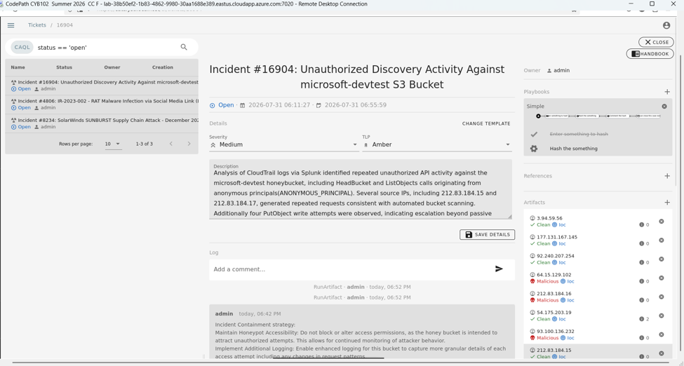  Analysis Notes:  We cross-referenced each source IP in VirusTotal to check for prior flags. A few stood out 64.15.129.102 and 93.100.136.232 were both flagged by SOCRadar and 212.83.184.16 came back flagged by two separate vendors. None of these IPs fall within any range we'd expect to see legitimate traffic from and since every request came through as ANONYMOUS_PRINCIPAL rather than an authenticated identity, it confirms this wasn't normal or authorized access.  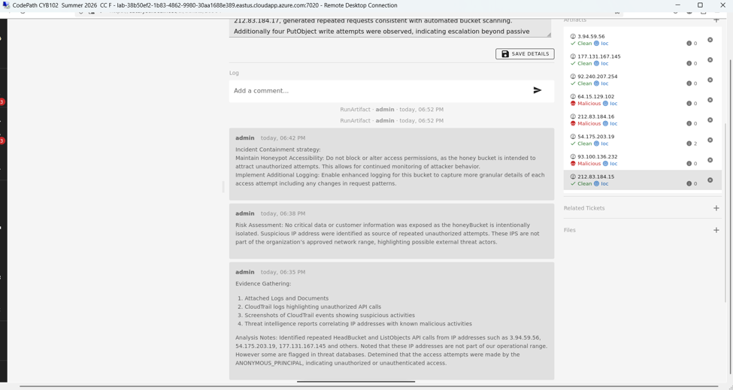  Monitoring Sources (or supplementary to Impact Analysis)  Looking at the full distribution of Repeated Attempts across all 600 events, the vast majority (92.3%) involved only a single attempt from a given IP, and another 6.3% involved just two attempts. This means the overwhelming majority of source IPs only interacted with the bucket once or twice consistent with broad, low-effort internet scanning. Against that baseline, the two outliers at 58 and 62 attempts stand out even more sharply, each accounting for only 0.3% of events individually but representing far more sustained, deliberate activity than anything else in the dataset.  This distribution also reinforces our source IP findings: the top 10 IPs by volume (led by 212.83.184.15 and 212.83.184.17) account for a disproportionate share of total traffic relative to the long tail of one-off scanners, supporting our decision to prioritize investigation of a small number of repeat offenders rather than treating all 170+ unique IPs as equally significant.  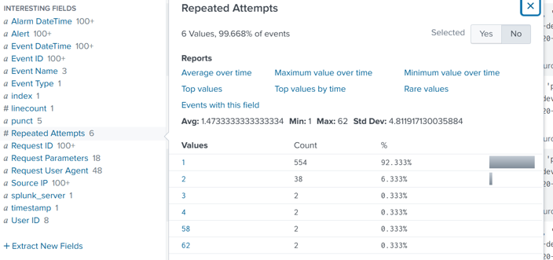  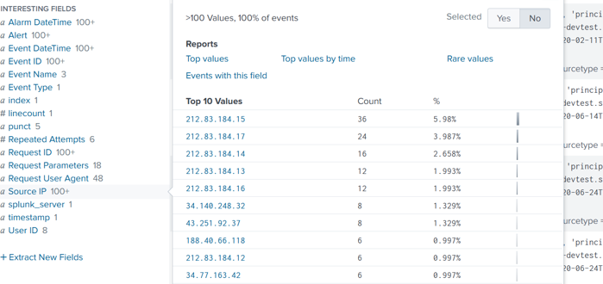  Evidence Gathering: Attached Logs and Documents  CloudTrail Logs (via Splunk):  We pulled the CloudTrail logs for the microsoft-devtest bucket into Splunk and ran a deduplicated search on Source IP, which returned 170 unique IPs across 301 total events all logged under the ANONYMOUS_PRINCIPAL account ID, confirming none of this traffic came from an authenticated or recognized user.  We also ran a frequency breakdown of source IPs to identify repeat activity. The top offenders were 212.83.184.15 (18 requests), 212.83.184.17 (12 requests), 212.83.184.14 (8 requests) and 212.83.184.13 (6 requests) a small handful of IPs responsible for a disproportionate share of the total traffic, which is a strong indicator of automated scanning rather than incidental one-off access.  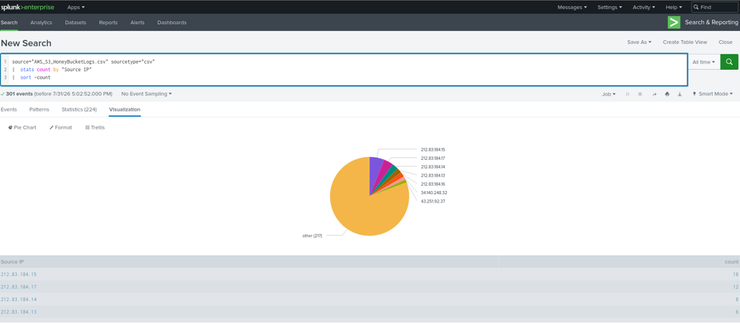  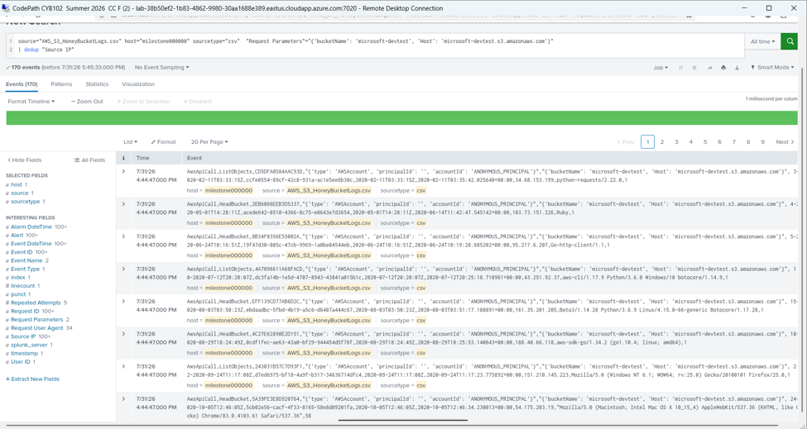  Screenshot: CloudTrail events highlighting suspicious activities  Repeated Attempts & IPs:  Source IP 3.94.59.56 logged 62 repeated attempts, and 54.175.203.19 logged 58 repeated attempts both significantly higher than any other source in the dataset and both using an identical Mozilla/Chrome user agent on macOS. This pattern suggests sustained, deliberate activity against the bucket rather than a one-off scan, making these two IPs the strongest candidates for further investigation.  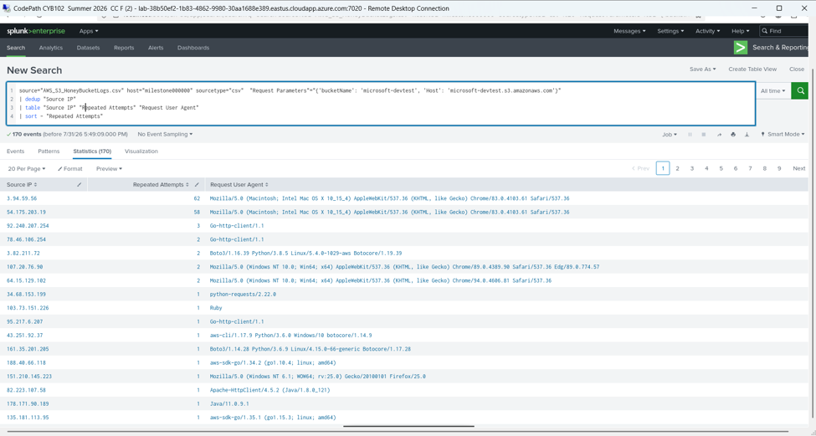  Anonymous Principal:  Across all 170 unique source IPs, every request carried an ANONYMOUS_PRINCIPAL accountId with no associated principalId, confirming that every single interaction with the bucket from the two heavy repeat offenders (3.94.59.56 and 54.175.203.19) down to the one-off scanners came from unauthenticated sources with no legitimate AWS identity tied to our organization. This consistency across the entire dataset rules out the possibility that any of this traffic was internal or authorized activity.  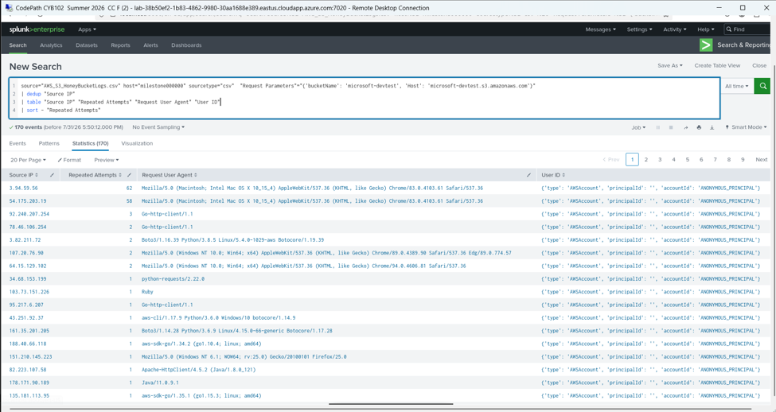  API Calls:  Breaking down the event type per source IP showed a clear split in behavior between the top two offenders: 3.94.59.56 (62 attempts) was making repeated ListObjects calls, while 54.175.203.19 (58 attempts) was making repeated HeadBucket calls. This distinction matters HeadBucket is typically used to confirm a bucket exists before attempting further action, while ListObjects attempts to enumerate its actual contents, so together these two IPs represent both stages of reconnaissance against the same target.  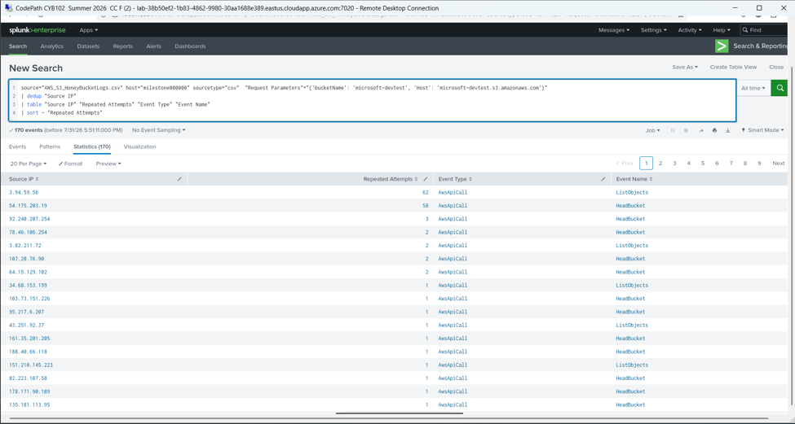  Threat Intelligence Reports: Correlating IP addresses with known malicious activities.  We cross-referenced our flagged IPs against VirusTotal to check for prior reputation data:  - 64.15.129.102 : flagged malicious by SOCRadar (1/91 vendors), located in Canada  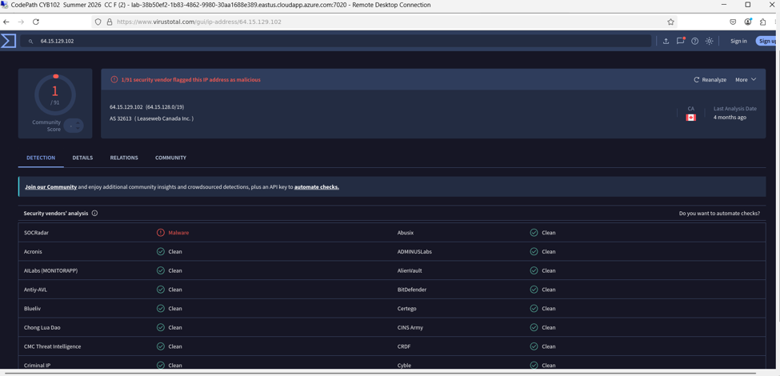  - 212.83.184.16 : flagged malicious by 2 vendors (Chong Lua Dao and GreenSnow), located in France  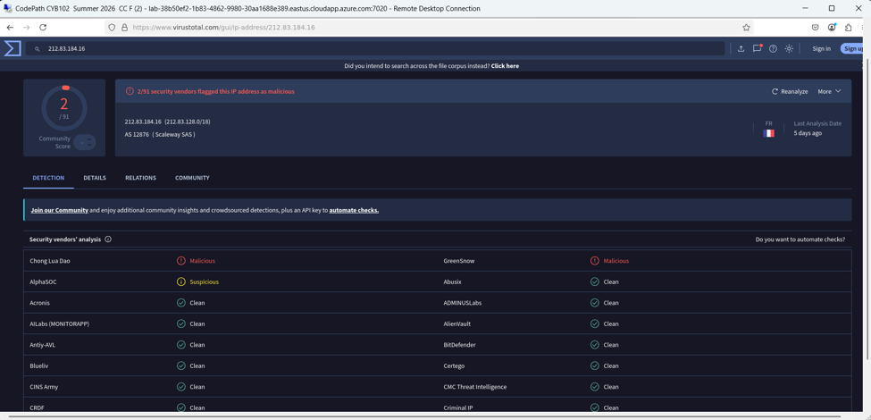  - 93.100.136.232 : flagged malicious by SOCRadar (1/91 vendors), located in Russia  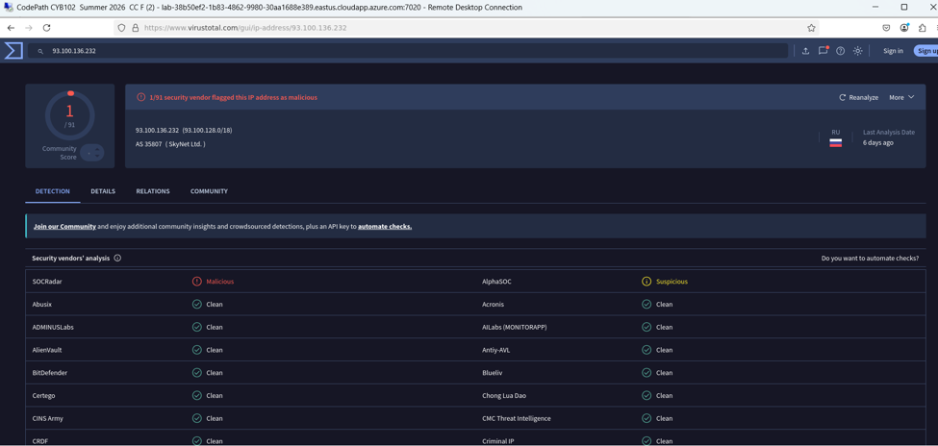  While the detection counts are low individually, the fact that these IPs appear in independent threat databases at all combined with their unauthenticated, high-frequency access to our honeybucket supports treating them as low-confidence but non-negligible external threat indicators rather than dismissing them as random noise.  Risk Assessment  - Data Exposure: Since microsoft-devtest is a honeybucket built for this exercise, it never held any real or sensitive data, so there was no actual data-loss risk regardless of how many unauthorized attempts occurred.  - Threat Level: We assessed this as Medium. While no real assets were at risk, the activity included confirmed malicious IPs (via VirusTotal) and two clear outlier IPs 3.94.59.56 (62 attempts) and 54.175.203.19 (58 attempts) showing sustained, targeted behavior rather than passive one-off scanning.  - External Threat Indicators: Every single one of the 170 unique source IPs we captured showed as ANONYMOUS_PRINCIPAL, and none fell within our organization's network range, indicating the activity came entirely from outside sources with no legitimate business reason to access the bucket.  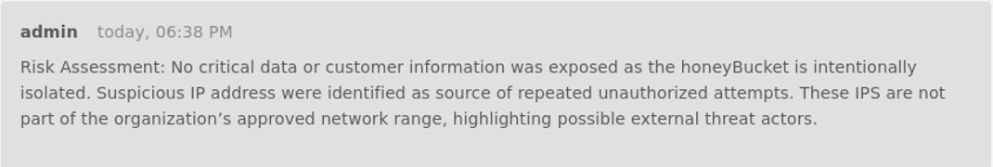  Key Actions Taken  - Kept the Honeybucket Live: We intentionally left the bucket accessible instead of blocking the offending IPs, since restricting access would have cut off our ability to keep observing attacker behavior over time.  - Logged Everything in Catalyst: Rather than letting findings sit in Splunk search results, we formally tracked this as Incident #16904 in Catalyst, documenting evidence, IP classifications, and analysis notes in one place for the team to reference.  - Correlated IPs Against Threat Intel: We ran our flagged IPs through VirusTotal to distinguish IPs with an actual malicious track record from ones that were just unfamiliar or unrecognized.  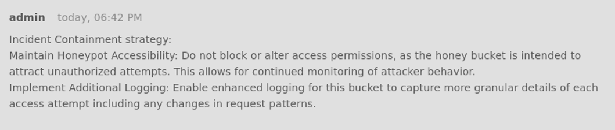  Lessons Learned & Behavioral Insights  The repeated, high-volume activity from a couple of IPs using identical user agents strongly suggests automated tooling rather than manual browsing a real person doesn't call ListObjects 62 times against the same bucket. We also noticed a clear pattern in what attackers were doing first: HeadBucket and ListObjects were by far the most common calls, meaning most activity was reconnaissance (confirming the bucket exists and checking its contents) rather than actual data manipulation which only showed up in a handful of PutObject attempts.  Future Recommendations  - Expand the honeypot program: Deploy additional honeybuckets with different naming conventions or permission structures to see if attacker behavior changes based on how "real" a bucket appears.  - Automate the detection we did manually: Configure GuardDuty or Security Hub to flag the same patterns we found by hand in Splunk (repeated HeadBucket/ListObjects from ANONYMOUS_PRINCIPAL) so this kind of reconnaissance gets caught in real time on production buckets, not just in a retrospective analysis.

Presentation Prep (Required)
Presentation Plan: What is your plan for the presentation? Please include a roadmap, flowchart, diagram, or outline.

Things to consider:
- What will you talk about, and in what order?
- Who will be talking at what times?
- What visual-aids will you use?
1. Kickoff & Project Goals (Viridiana Ramos Ayala)
- What we set out to do with this Data Dig and why honeypots matter as a detection strategy in real security operations
2. The Dataset (Shireen M A Sheikh)
- AWS S3 Honeybucket Logs (microsoft-devtest)
- Source: Security Datasets project - link included in slide
3. How We Monitored the Bucket
- Ingested CloudTrail logs into Splunk for searching and correlation
- Captured fields: Source IP, Event Name, Request Parameters, User Agent, Repeated Attempts
4. Threat Intelligence (Maria Hossain)
- Broke down unauthorized access attempts by IP and behavior pattern
- Flagged standout IPs (3.94.59.56 – 62 attempts, 54.175.203.19 – 58 attempts) and cross-checked reputations via VirusTotal
- [Screenshots: Splunk stats table, VirusTotal results]
5. Tracking It in Catalyst
- Walked through how we opened and documented Incident #16904
- Logged evidence, risk assessment, and containment notes directly in the platform
6. What This Means for Security Posture
- Key takeaways from the data: most activity was automated recon (HeadBucket/ListObjects), with a few IPs escalating to PutObject
7. What We'd Recommend (Elhassan)
- Concrete next steps: tighter alerting, blocklisting repeat offenders, expanding the honeypot program
8. Wrap-Up

Draft of Visual Aids (Required)

Visual Aids Draft: Please include a draft of your visual aids for the presentation. This may include slides, screen recordings, GIFs showing demos, or more!

Note: If you link to Google Docs/Slides/etc, be sure your document is set to “Anyone with the link can view”!
https://docs.google.com/presentation/d/10HYsvqhF4HpdZ0v5X0rcMDgNuxdxbJXEwMyeY3g9Fds/edit?usp=sharing

Stretch Feature: One-Pager (Optional)

One-Pager Draft: Please include a draft of a one-page handout, or “one-pager”, you can give your audience prior, during, or after the presentation. One-pagers can be used both to provide extra context and summarize key information.

Note: If you link to Google Docs/Slides/etc, be sure your document is set to “Anyone with the link can view”!
Document:
onepagerProj
Presentation:
CYB102_Group49_DataDig_DemoDay - Google Slides

Milestone Workbook (Optional)
Please use this space to brainstorm, draft, share resources, and otherwise plan out your project!

Submission Checklist
👉Check off each of the features you have completed. You will only be graded on the features you check off.

Required Features
- Answer each of the key aspect questions:
  - Monitoring Sources
  - Identified Assets
  - Impact Analysis and Triage
  - Threat Intelligence
  - Recommended Remediation
  - Case Management System
- Your presentation plan: A roadmap, outline, or diagram
- A draft of your visual aids (slides, screen recordings, etc)

Stretch Feature
- Submit a draft for a one-pager summarizing your project for the audience

💡Tip: You can see specific grading information, including points breakdown, by going to 🔗 the grading page on the course portal.

